Kem Chan
CS 360
Mar 27, 2026
4-4 Assignment: UI Design

The application that I have decided to go with for this assignment is the Calendar application that is used on daily usage on my Samsung mobile device. Being able to lay out everything from movies, trips, and bill due dates on the calendar is very beneficial with everything it has to offer. The Calendar app is how I can keep track of when certain bills are due and when certain events are happening by keeping me organized and easily accessing it whenever it is necessary. The calendar application has the option to add a widget on the home screen of the mobile device. In the instance of being in a rush, the calendar is available a touch away at the fingertips and can be viewed for the events in the upcoming week from the widget. Upon opening the calendar application, you can view the events for the whole month with the chance to see all the events under a selected day. All that would be needed to do is select the day you want to view and it is further broken down hourly starting from 12am to 12pm by being able to view the events on the day. Within each event, you can set a notification that can be sent on the phone as late as 10minutes before the event to as early as the day before. This feature is the one that I liked the most since sometimes I do forget the events on certain days to see what was going on.
Having the notifications on my phone is always a helpful reminder but there were a few things that could personally change to make it better. The first thing I would like to expand is where the whole month and year would fit across the top screen. The way to plan on the calendar application is by clicking the arrow that is featured beside the month, and you can see the year that is currently viewed. If it is missed, then all the visible parts of the month that is being viewed would also be removed. The second thing I would add is more color options for coding each event, Calendar application does have color coding options, but when it came to busier months it would be helpful to have more like a color wheel, that would pop up under scheduling an event under the color window. The last thing I would modify is get rid of the traditional events that would not really need on my calendar and some of them would like to automatically on the calendar application. There was no option for what you could choose and what you cannot.
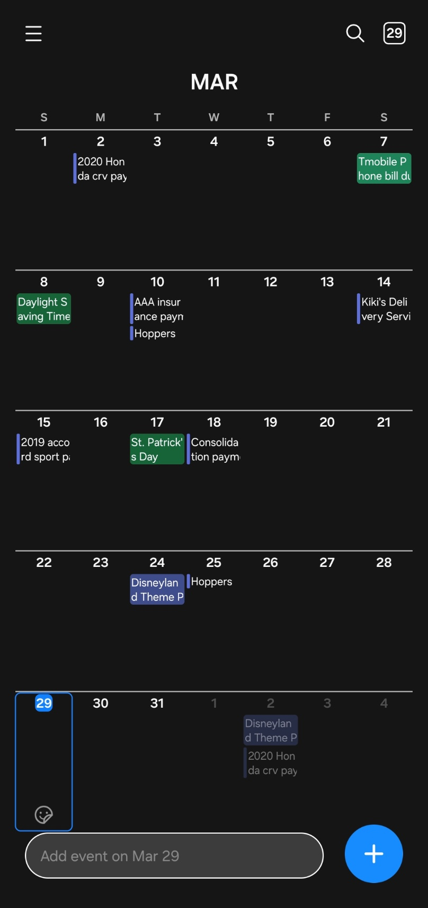
Sample of calendar application with minimal events
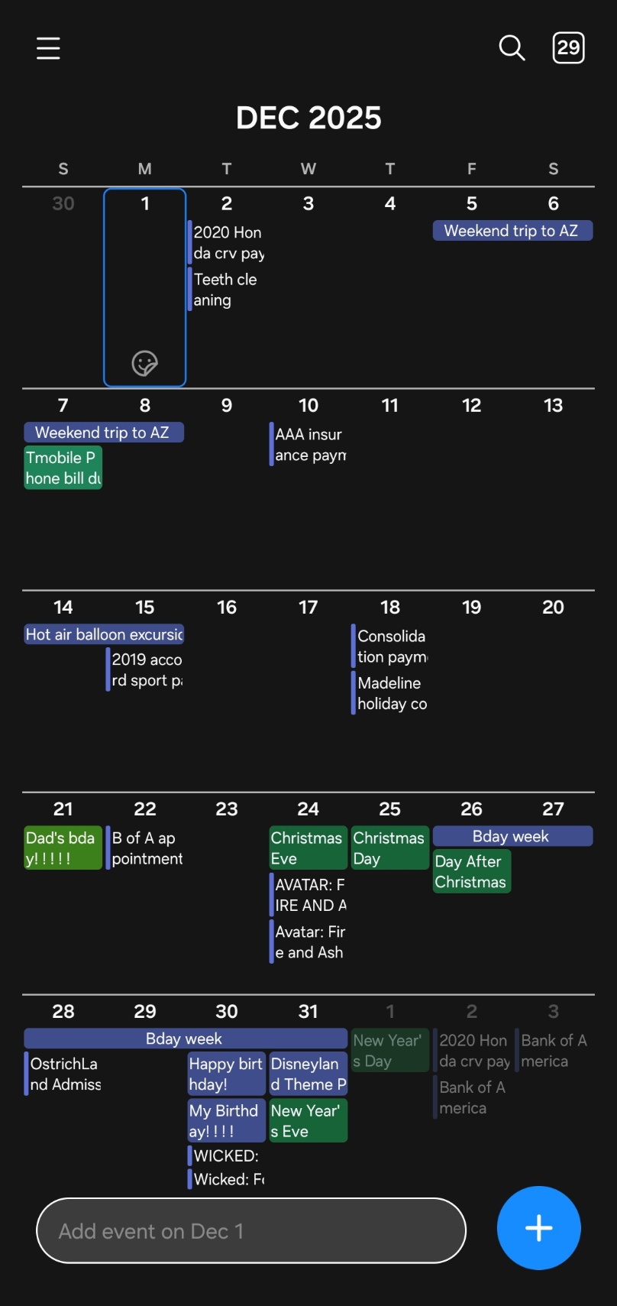
Sample of calendar application with more eventful activities
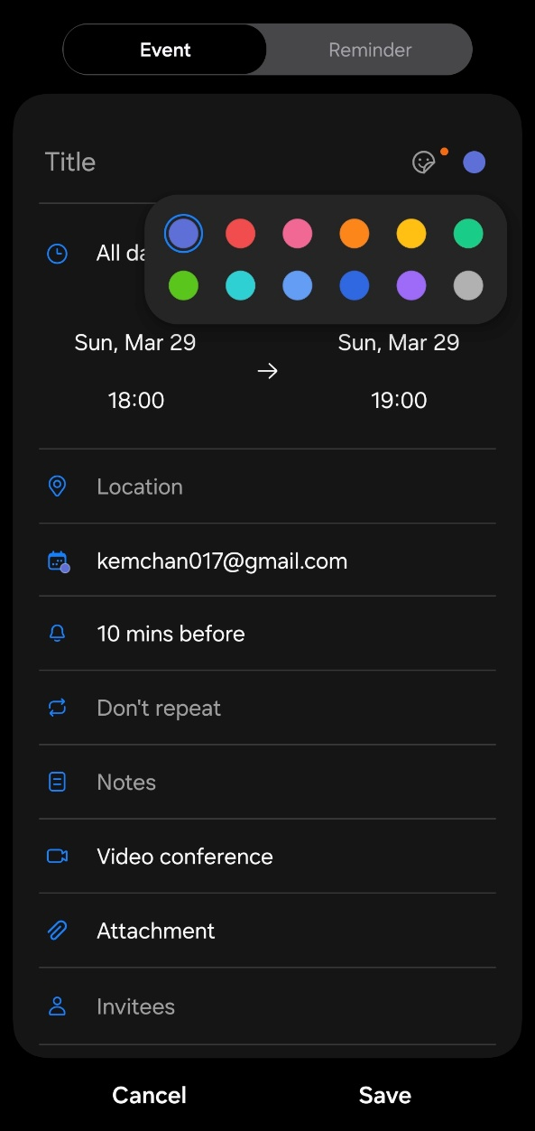
Sample of color options when creating event reminder on calendar
Red circle is where the color wheel should go
Reference
Core App Quality (03/26/2026)
https://developer.android.com/docs/quality-guidelines/core-app-quality

